DESCRIPTION

Surface Terrazzo Refinishing by DANCER is a durable and economical flooring solution that provides a wax-free surface to existing terrazzo floors that had been waxed, abandoned, or covered with other flooring surfaces. This work typically involves patching the floor as well.

[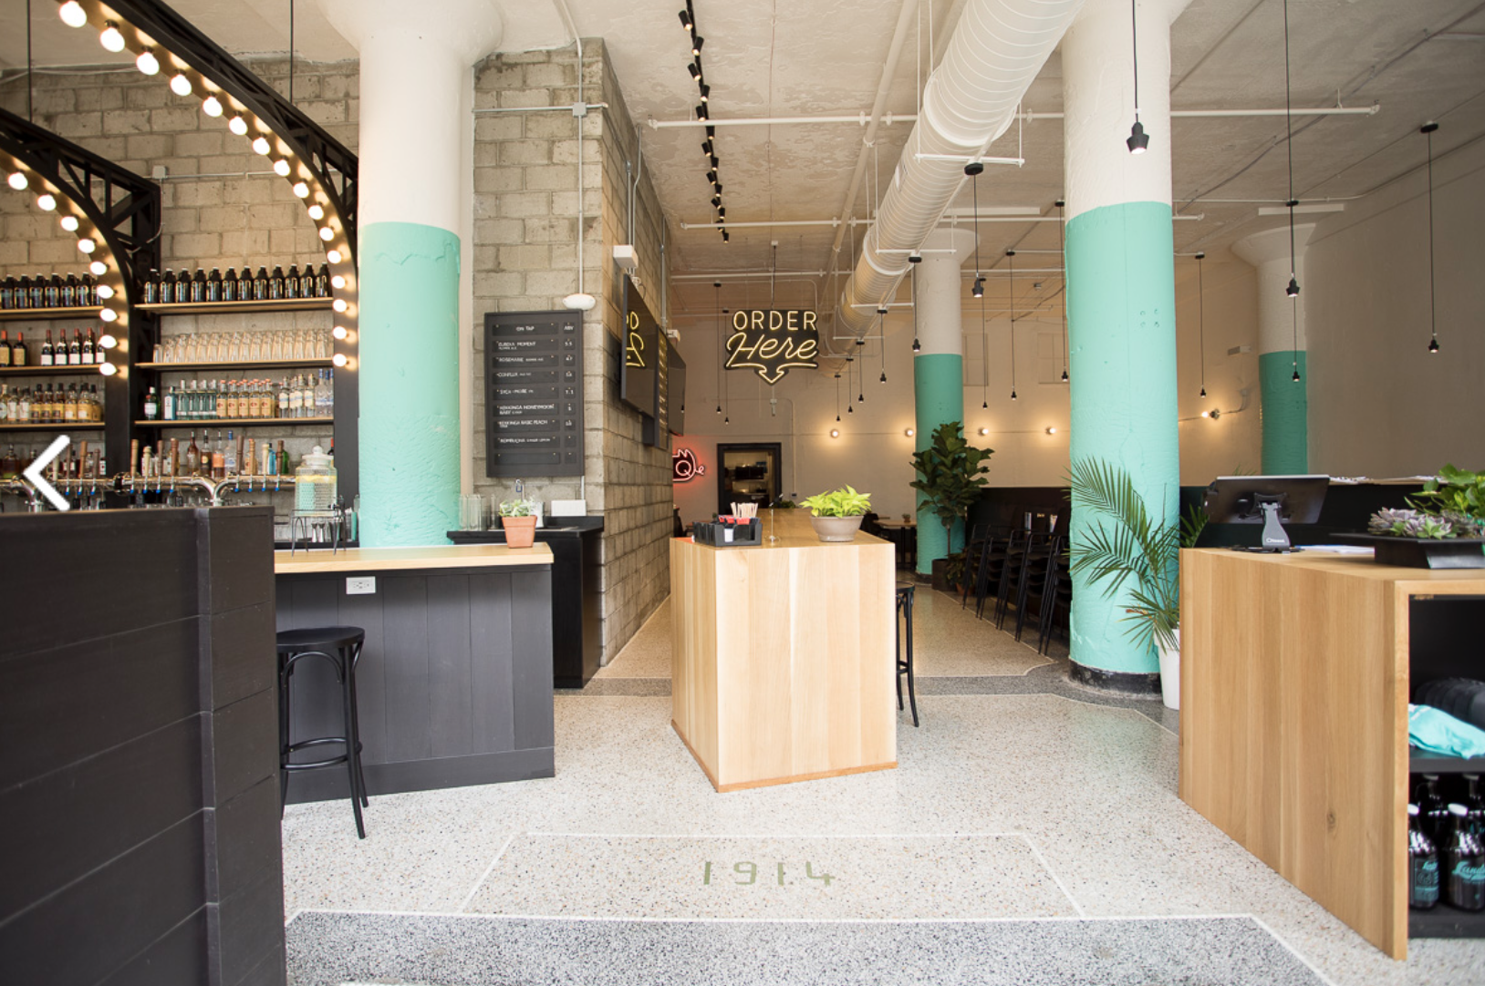](https://dancerconcrete.com/surface-terrazzo/)

**Durability.** Terrazzo offers one of the most durable flooring options available.

**Affordable.** More cost-effective than replacement with other hard surfaces.

**One-of-a-Kind.** Colors, patching, and aggregate exposure are unique to each floor.

**History.** Honoring and preserving our historic building materials.

**Additional Options**

* Patching. Custom color matching for patches.
* CAST Products. Precast terrazzo elements such as stairs and base.

LIMITATIONS: Some cement-based terrazzo floors and some extinct stones will have limited availability for color matching.

QUICK SPEC

SURFACE TERRAZZO REFINISHING BY DANCER

FINISHED SHEEN: SATIN

Contact: Nick Dancer, 260-415-1951, nickdancer@dancerconcrete.com

DANCER offers AIA Accredited Courses for Polished Concrete, Epoxy Coatings, and Terrazzo Flooring in your office or ours. <https://dancerconcrete.com/continuing-education/>

Please contact us for budget pricing, samples, or design considerations.

PART 1 – GENERAL

1.1    SUMMARY

1. Section includes products and procedures for refinishing and patching existing terrazzo floors.

1.2    SUBMITTALS

1. Product Data: Manufacturer’s technical literature for each product indicated, specified, or required. When applicable, specify whether the floor is cement-based or epoxy-based terrazzo.
2. Samples: To be done on-site as needed to show refinishing.

1.3    QUALITY ASSURANCE

1. Sample: Approval of sample mix design to be used in each color of the floor. One cured sample per color. Produce full-scale panels as needed.
2. Locate panel as indicated or, if not indicated, as directed by the Architect.
3. Maintain field sample panels during construction in a quiet location as a standard for judging completed work.
4. Terrazzo Installer Qualifications: Company experienced in performing work similar in design, products, and extent to scope of this Project; with a record of successful in-service performance; and with sufficient production capability, facilities, and personnel to product specified work.
5. Manufacturer Qualification: Approved by manufacturer to apply products.

1.4    FIELD CONDITIONS

1. All flooring to be refinished as noted on prints. All refinishing to be completed within ¼’’ of wall surface with expectation that floor base will cover this area. Any areas needed to be refinished closer than ¼” to be noted. All inside corners are to be completed with an oscillating multi-tool fitted with abrasives to achieve similar results in all hard-to-reach areas.

1.5 WARRANTY

1. DANCER warrants that material and installation are free from defects and will perform substantially.
2. DANCER’s liability with respect to this warranty covers labor and material of installation for a period of two years.

PART 2 – PRODUCTS

2.1    ACCEPTABLE MANUFACTURES

1. Basis of Design: for products and materials specified Surface Terrazzo Refinishing System installed by DANCER, Fort Wayne, Indiana. Products of the manufacture are approved provided compliance with all technical requirements as specified herein:
2. DANCER, Surface Terrazzo Refinishing System, Fort Wayne, Indiana. Contact: Nick Dancer, 260-415-1951, [nickdancer@dancerconcrete.com](mailto:nickdancer@dancerconcrete.com)
3. 3M Stone Floor Protection System

2.2 PERFORMANCE REQUIREMENTS

1. Level of Floor Reflection
2. Finished Gloss Level 1 – Satin – 400 Grit Finish

2.3    POLISHING EQUIPMENT

1. Field Grinding and Polishing Equipment.
2. A multiple head, counter rotating, walk behind machine, with diamond tooling affixed to the head for the purpose of grinding terrazzo. Excludes janitorial equipment.
3. If dry grinding, honing, or polishing, use dust extraction equipment with flow rate suitable for dust generated, with squeegee attachments.
4. If wet grinding, honing, or polishing, use slurry extraction equipment suitable for slurry removal and containment prior to proper disposal
5. Edge Grinding and Polishing Equipment: Hand-held machine which produces same results, without noticeable differences, as field grinding polishing equipment.

2.4    REPAIR PRODUCTS

1. Grout Coat: An epoxy-based filler used to fill in surface imperfections, small cracks, and pop-outs on the floor.
2. Repair Mortar: An epoxy-based repair mortar mixed with sand and/or stone aggregate is used to repair the floor in large cracks, crevices, divots, or full panel replacement. Product to be colored to coordinate with the final floor color selected.
3. DANCER; Surface Terrazzo

2.6    LIQUID FLOOR TREATMENTS

1. (KEEP for cement-based terrazzo; REMOVE for epoxy-based terrazzo.) Penetrating Liquid Floor Treatments for Cement Terrazzo Densifier: Clear, waterborne solution of inorganic silicate or siliconate materials and proprietary components; odorless, that penetrates, hardens, and is suitable for cement surfaces.
2. Products: DANCER; StrongTread Densifier
3. Ameripolish Densifier
4. Impregnating Stain Protection: Non film forming stain and food resistant penetrating sealer designed to be applied to finished terrazzo flooring.
5. Products: DANCER; StrongTread Stain Guard PSG
6. Ameripolish SR2+

PART 3 - EXECUTION

For More Detailed Steps on the Process for your particular project, please call Nick Dancer with DANCER – 260-415-1951 or by email at [nickdancer@dancerconcrete.com](mailto:nickdancer@dancerconcrete.com). Polishing tooling and steps vary depending on job site conditions. The Execution section can be written for your specific job.

3.1 EXAMINATION

1. Verify that floor surfaces are acceptable to receive the work of this section.
2. Verify that flaws in terrazzo have been patched and joints filled with methods and materials suitable for further finishes.

3.2 GENERAL

1. Apply materials in accordance with manufacturer's instructions.

3.3 PREPARATION

1. Verify that the surface is in such a condition to result in satisfactory final results.
2. Protect adjacent non-finished areas from damage, overflow, overspray, etc., and immediately remove excess material.

3.4    REFINISHING

1. All flooring to be refinished as indicated.
2. Machine grind floor surfaces to receive polished finishes level and smooth, hand tool around all walls, openings and obstructions as necessary to approved mock-up.
3. (REMOVE if visible pitting/pin holes are not present.) Treat surface imperfections with a grouting process or repair mortar.
4. (REMOVE for epoxy-based terrazzo.) Apply penetrating liquid densifier for cement terrazzo in polishing sequence and according to manufacturer's written instructions, allowing recommended drying time between successive coats.
5. Continue the refinishing with progressively finer-grit diamond polishing pads to gloss level, to match approved mock-up and specified gloss level.
6. Apply specific stain guard treatment to floor and complete final burnishing with appropriate diamond impregnated burnishing pad or buffing pad.
7. Control and dispose of waste products produced by grinding and polishing operations.
8. Neutralize and clean polished floor surfaces.

3.5  PROTECTION

1. Covering: After completion of work, protect terrazzo from subsequent construction activities with protective covering as required.
2. Maintenance: To be handled by the owner. A terrazzo conditioning treatment detailed in the Maintenance Guide to be followed for best durability.

END OF SECTION 09 66 00