DESCRIPTION
TreadWell Decorative Quartz is an epoxy system that incorporates a broadcast quartz coating to be a durable and seamless floor. It is a medium duty flooring system, designed for commercial and industrial settings requiring a high-end aesthetic. The system provides slip and stain resistance, durability, and countless color combinations.

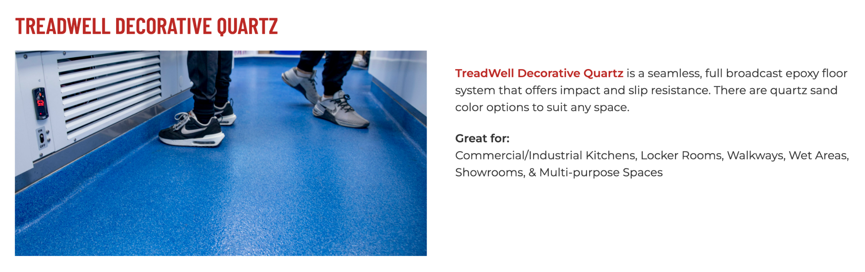
https://dancerconcrete.com/treadwell-decorative-quartz/

Durability. One of the most abrasion resistant floors available. The best choice for cleated locker rooms.
Slip Resistant. The floor’s texture provides slip resistance for wet areas like kitchens and showers.
Customization. Our variety of colors can be matched to your brand.

Additional Options
- Integral Cove. Get a seamless transition between floor and wall.
- Mortar Base. Provides additional impact resistance and serves as a moisture mitigation system. Includes a 5 year warranty.
- GriP. Add to improve slip resistance in wet areas.
- GriT. Add to improve abrasion resistance.

QUICK SPEC
DANCER CONCRETE DESIGN, TREADWELL DECORATIVE QUARTZ
COLOR: SPECIFIED BY ARCHITECT
FINISHED SHEEN: GLOSS, SATIN, GLOSS W/GRIP, OR GLOSS W/GRIT
Contact: Nick Dancer, 260-415-1951

Dancer Concrete Design offers AIA Accredited Courses for Polished Concrete, Epoxy Coatings, and Terrazzo Flooring in your office or ours. www.dancerconcrete.com
Please contact us for budget pricing, samples, or design considerations.
Nick Dancer. nickdancer@dancerconcrete.com c. 260-415-1951.

PART 1 – GENERAL

1.1 SUMMARY

- Section includes products and procedures for a decorative quartz broadcast flooring system designated area as specified herein as indicated on drawings.

- The work shall consist of preparation of the concrete substrate, furnishing and application of all of the steps and procedures relating to the installation of this flooring including primer, body coat, broadcast coat, encapsulation coat and final high-wear topcoat.

- Cove base, if selected to be noted on the finish schedule. Available in 4” and 6” installation.
- Relative humidity based moisture readings to be done by installation contractor prior installation. All readings must read below 75% RH before installation. Epoxy contractor to submit readings to the General Contractor. 3rd party moisture readings are also recommended.

1.2 SUBMITTALS

- Product Data: Manufacturer’s technical literature for each product indicated, specified, or required.

- Samples: For each type of exposure, finish or color. Sample size minimum 4” x 6”.

1.3 QUALITY ASSURANCE

- Qualifications: Company experienced in performing work similar in design, products, and extent to scope of this project; with a record of successful in-service performance; and with sufficient production capability, facilities, and personnel to product specified work.

- Manufacturer Qualification: Approved by the manufacturer of epoxy products.

1.4 FIELD CONDITIONS

- Concrete flooring to be available and open for preparation steps. Once the floor is prepared, only allow foot traffic on the exposed surface.

- Adequate lighting to be provided by the General Contractor or Owner prior to the installation of flooring.

- Area for installation to be maintained at a temperature between 60 F – 75 F. Area for installation must be in controlled conditions.

- A sufficient area for staging and mixing materials to be provided.

- Building to be closed in with no water intrusion on the surface during the installation or curing process.

- Existing Concrete Surfaces

- Prohibit improper application of liquid membrane forming curing compounds, vehicles parking over the concrete surface, pipe-cutting operations over concrete surface, storage of items on concrete less than 28 days old, petroleum, oil, hydraulic fluid, and acids as these may all affect final finish of floor treatment.

1.5 WARRANTY

- Dancer Concrete Design warrants that material and installation is free from defects and will perform substantially.

- Dancer Concrete Design’s liability with respect to this warranty covers labor and material of the installation for a period of two years.

PART 2 – PRODUCTS

2.1 ACCEPTABLE MANUFACTURES

- Basis of Design: for products and materials specified from TreadWell Decorative Quartz System by Dancer Concrete Design, Fort Wayne, Indiana. Single source warranty carried by installer. Products of the manufactures are approved provided compliance with all technical requirements as specified herein:

- Dancer Concrete Design, TreadWell Decorative Quartz, Fort Wayne, IN. Contact Nick Dancer, 260-415-1951, nickdancer@dancerconcrete.com
- Dur-A-Flex, Inc.
- Sherwin Williams High-Performance Flooring Systems

2.1 PRODUCTS

- Primer – Clear, catalyzed, water-based primer to be used on prepared concrete surface at an application rate to seal the surface.

- Dancer Concrete Design; TreadWell 4:1 Water-Based Epoxy Primer, resin and hardener.

- Body Coat: Clear, 100% solids epoxy body coat applied to the surface as a base for the decorative quartz broadcast.

- Dancer Concrete Design; TreadWell 100% Solids Clear Epoxy Body Coat, resin and hardener.

- Broadcast: 40-S Colored Quartz Granular

- Dancer Concrete Design; Torginol Color Granules.

- Encapsulation Coat: Clear, 100% solids epoxy coat with UV inhibitors epoxy used to encapsulate broadcasted media.

- Dancer Concrete Design; TreadWell 100% UV-Clear Epoxy Top Coat, resin and hardener.

- High-Wear Topcoat - Clear, catalyzed, water based urethane to be used over epoxy finish. Finishes available: Gloss Grit, Satin Grit, Satin Grit w/GRIP (for wet areas).

- Dancer Concrete Design; TreadWell 4:1 Water-Based Urethane.

2.3 REPAIR PRODUCTS

- Grout Coat: A cementitious based, acrylic modified slurry used to fill in surface imperfections, small cracks and pop-outs on the floor.

- Dancer Concrete Design; Repair Grout Coat

- Repair Mortar: A rapid-setting resin based repair mortar mixed with sand and/or stone aggregate to repair the floor in large cracks, crevices and divots.

- Dancer Concrete Design; Polishing Repair Mortar

PART 3 - EXECUTION

3.1 EXAMINATION

- Examine substrates, area and conditions, regarding moisture content, installation and any condition that could affect flooring performance.

3.2 PREPARATION

- General

- New and existing concrete surfaces to be free of contaminants that may inhibit proper bonding of the concrete surface. No acrylic concrete sealers to be used as a curing agent.
- Moisture testing to be done by relative humidity testing, ASTM F 2170. For standard installation readings must be below 75% RH.
  - If readings are above 75% RH then Dancer Concrete Design, 5-Year Moisture Block Primer must be installed as a primer.
- The surface shall be mechanically profiled by shot blasting or grinding equipped with a HEPA vacuum system to maintain air quality during preparation. Minimum profile must be CSP 3-4 as detailed by ICPI.
- Cracks and non-moving control joints to be repaired per manufacturer's specification. All cold joints to be honored through the installed system and filled with an elastomeric joint filler.

3.3 APPLICATION

- General

- The system shall follow the contour of the floor unless noted patching or leveling specified by the Architect.
- The finish shall have a neat, clean, and organized appearance with straight lines, and well defined boundaries of the installation.

- Primer

- The primer shall be TreadWell 4:1 WB Epoxy Primer. The catalyzed product shall be mixed per manufacturer's recommendation.
- The primer shall be applied by squeegee and roller at the rate of 150 SF per gallon.

- Broadcast Coat

- The broadcast coat shall be applied as a double broadcast system.
- The body coat shall be TreadWell 100% Solids Clear Epoxy Body Coat. The catalyzed product shall be mixed per manufacturer's recommendation.
- The body coat shall be applied by squeegee and roller at the rate of 100 SF per gallon.
- The broadcast aggregate shall be Torginol Color Granules 40-S.
- The broadcast shall be performed by an installer on spiked cleats. The broadcast to be applied to the surface until rejection into the ‘wet’ base coat. The application is 0.5 lbs. of quartz per SF.
- Excess quartz media to be scraped and swept clean once the body coat has fully cured.
- The second body coat shall be applied by squeegee and roller at the rate of 100 SF per gallon.
- The second broadcast to be applied to the surface until rejection into the ‘wet’ base coat. The application is 0.5 lbs. of quartz per SF.
- Excess quartz media to be scraped and swept clean once the body coat has fully cured.

- Encapsulation Coat

- The encapsulation coat shall be TreadWell UV-Clear 100% Solids Epoxy. The catalyzed product shall be mixed per the manufacturer's recommendation.
- The encapsulation coat shall be applied over the quartz leaving an even stipple texture with no puddles or smooth spots at the rate of 100 SF per gallon.

- High-wear Topcoat

- The topcoat shall be TreadWell 4:1 Water-Based Urethane. The catalyzed product shall be mixed per the manufacturer's recommendation.
- The topcoat shall be applied by roller at the rate of 400 SF per gallon.

3.3 PROTECTION

- The flooring shall be allowed to cure for 24 hours before other trades walk on the surface. The floor shall be allowed to cure 48 hours from final topcoat until construction activities or setting of items on the floor. When setting items on the finished surface they shall be placed on cardboard.

- Covering: After completion of sealing allow for proper cure and then protect sealed floors from subsequent construction activities with protective covering. No tape to be used on the finished surface.

END OF SECTION 09 67 23

