DESCRIPTION
Surface Polish supplied and installed by Dancer Concrete Design is a cement-based overlay installed at a ¼” thick. The finished product resembles traditional Class B aggregate polished concrete floors, and can be used in the same installations as traditional polished concrete.

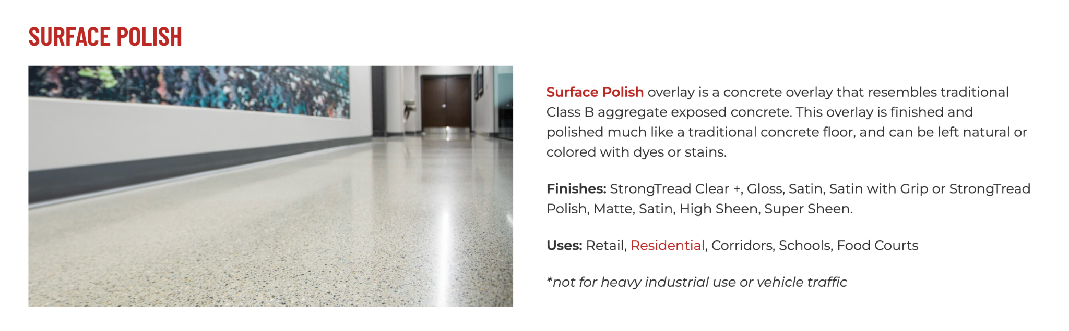
https://dancerconcrete.com/surface-polish/

Uniform Design. Provides more consistent aggregate exposure across the floor.
Customizable. Choose from dyes or stains.
New Surface. Covers trenching, repairs, and unlevel surfaces.

Additional Options
- Penetrating Dye or Reactive Stain. Define your space by adding color to your floors.
- Custom Logos. Leave a long lasting mark with your brand.

LIMITATIONS: Not to be used in kitchen environments with fryers or commercial dishwashing equipment. Moderate vehicle traffic only.

QUICK SPEC
SURFACE POLISH OVERLAY, DANCER CONCRETE DESIGN
COLOR: TBD BY ARCHITECT FROM MANUFACTURERS FULL RANGE
FINISH: TBD BY ARCHITECT – POLISHED OR SEALED SURFACE
Samples of colors and finishes provided by Dancer Concrete Design.
Contact: Nick Dancer, 260-415-1951

Dancer Concrete Design offers AIA Accredited Courses for Polished Concrete, Epoxy Coatings, and Terrazzo Flooring in your office or ours. https://dancerconcrete.com/continuing-education/
Please contact us for budget pricing, samples, or design considerations.
Nick Dancer. nickdancer@dancerconcrete.com c. 260-415-1951.
PART 1 – GENERAL

1.1 SUMMARY

- Section includes products and procedure for a polished concrete floor topping designated area as specified herein as indicated on drawings.
- The work shall consist of preparation of the concrete substrate, furnishing and application of all the steps and procedures relating to the installation of this flooring including primer, sand broadcast and installation of ¼” floor topping to then be polished.

- Relative humidity based moisture readings to be done by installation contractor prior installation. Epoxy primer contractor to submit readings to the General Contractor. 3rd party moisture readings are also recommended.

1.2 SUBMITTALS

- Product Data: Manufacturer’s technical literature for each product indicated, specified, or required.
- Samples: For each type of exposure, finish or color. Sample size minimum 5” x 5”.

1.3 QUALITY ASSURANCE

- Qualifications: Company experienced in performing work similar in design, products, and extent to scope of this project; with a record of successful in-service performance; and with sufficient production capability, facilities, and personnel to product specified work.

- Manufacturer Qualification: Approved by the manufacturer of topping products.

1.4 FIELD CONDITIONS

- Concrete flooring to be available and open for preparation steps. Once the floor is prepared only allow foot traffic on the exposed surface.
- Adequate lighting to be provided by the General Contractor or Owner prior to the install of flooring.
- Area for installation to be maintained at a temperature between 50 F – 75 F. Area for installation must be in controlled conditions.
- A sufficient area for staging and mixing materials to be provided.
- Building to be closed in with no water intrusion on the surface during the installation or curing process.
- Existing Concrete Surfaces

- Prohibit improper application of liquid membrane forming curing compounds, vehicles parking over the concrete surface, pipe-cutting operations over concrete surface, storage of items on concrete less than 28 days old, petroleum, oil, hydraulic fluid, and acids as these may all affect final finish of floor treatment.

1.5 WARRANTY

- Dancer Concrete Design, warranty that material and installation is free from defects and will perform substantially.
- Dancer Concrete Design’s liability with respect to this warranty covers labor and material of the installation for a period of two years.

PART 2 – PRODUCTS

2.1 ACCEPTABLE MANUFACTURES

- Basis of Design: for products and materials specified from SURFACE Polish by Dancer Concrete Design, Fort Wayne, Indiana. Single source warranty carried by installer. Products of the manufactures are approved provided compliance with all technical requirements as specified herein:

- Dancer Concrete Design, Surface Polish Overlay, Fort Wayne, IN. Contact Nick Dancer, 260-415-1951, nickdancer@dancerconcrete.com
- Rapid Set by CTS, TRU-PC Topping

2.1 PRODUCTS

- Primer

- A high-performance 100% solids – no VOC, moisture tolerant primer to be used with cementitious overlays
  - Dancer Concrete Design; Surface 2:1 Epoxy Primer, resin and hardener.

- Topping

- A pre-packaged, high-performance, self-leveling cementitious topping that can subsequently be ground and polished or ground and sealed to provide the aesthetic of Class B polished concrete.
  - Dancer Concrete Design; Surface Overlay

2.3 REPAIR PRODUCTS

- Grout Coat

- A cementitious based, acrylic modified slurry used to fill in surface imperfections, small cracks and pop-outs on the floor.
  - Dancer Concrete Design; Repair Grout Coat

PART 3 - EXECUTION

3.1 EXAMINATION

- Examine substrates, area and conditions, regarding moisture content, installation and any condition that could affect flooring performance.

3.2 PREPARATION

- General

- New and existing concrete surfaces to be free of contaminants that may inhibit proper bonding of concrete surface.
- Moisture testing to be done by relative humidity testing, ASTM F 2170.
- The surface shall be mechanically profiled by shot blasting or grinding equipped with a HEPA vacuum system to maintain air quality during preparation. Minimum profile must be CSP 3-4 as detailed by ICPI.
- Cracks and non-moving control joints to be repaired per manufacturer's specification. All cold joints to be honored through the installed system and filled with an elastomeric joint filler.

3.3 APPLICATION

- General

- The system shall follow the contour of the floor unless noted patching or additional leveling specified by the Architect.
- The finish shall have a neat, clean, and organized appearance with straight lines, and well defined boundaries of the installation.
- Zinc terrazzo divider strips to be placed as needed to define boundary limits for application. Architect to specify noted plan if these are to be used in a more specific way.

- Primer

- The primer shall be Surface 2:1 Primer. The catalyzed product shall be mixed per manufacturer's recommendation.
- The primer shall be applied by squeegee and roller at the rate or 100 SF per gallon with a quartz sand broadcasted into the wet film.

- Topping

- The Topping shall be Surface Overlay. The topping product shall be mixed per manufacturer's recommendation.
- The topping shall be applied over a sand broadcast primer at a coverage of 16 SF per mixed bag or 0.60 cu ft.

- Finishing

- The finishing process selected shall be detailed in additional specifications.

3.3 PROTECTION

- The flooring shall be allowed to cure for 24 hours before other trades walk on the surface. Floor to be protected by abrasive traffic that will mark or divot concrete surface and all oil or acidic spills.

END OF SECTION 03 53 00

