DESCRIPTION
TreadWell Decorative Chip, supplied and installed by Dancer Concrete Design, is a multi-step, multi-application of epoxy products, colored ¼’’ vinyl chip media, and high-wear urethane finish. This system is typically specified in areas subject to conditions such restrooms, dining facilities, multi-purpose spaces, garages, light-duty kitchens, or wherever a decorative, medium abrasion resistant floor is required. Total thickness is ⅛”.

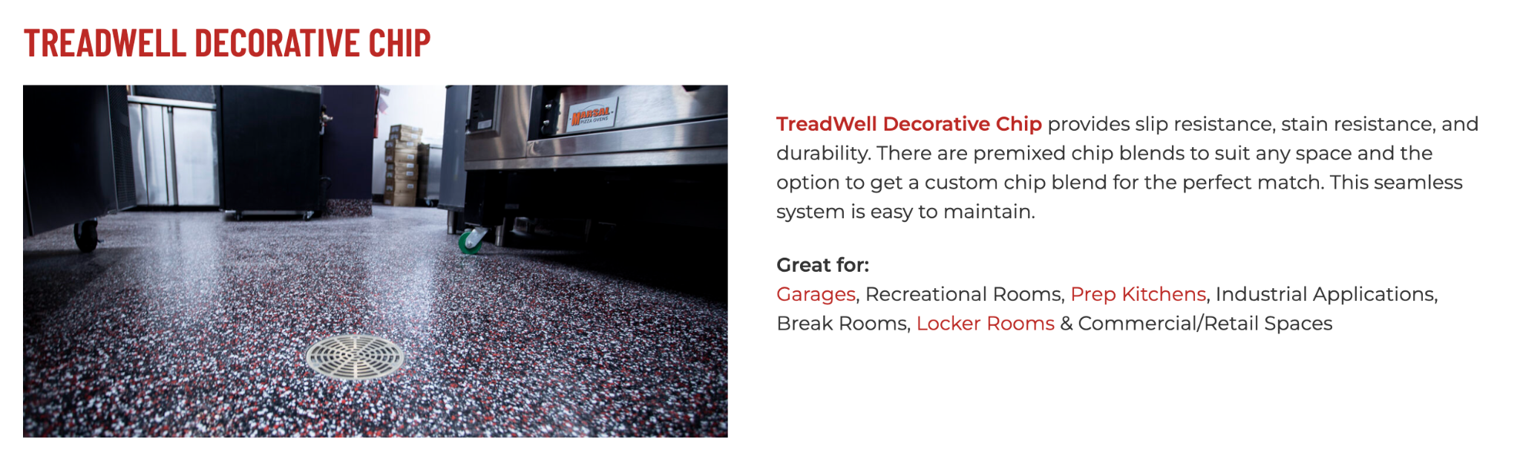
https://dancerconcrete.com/treadwell-decorative-chip/

Durability. Additional abrasion resistance over solid color epoxy systems.
Slip Resistant. Orange peel finish allows for mop cleaning.
Customization. Our variety of colors can be matched to your brand.

Additional Options
- Flexible primer and base to multi-story, wood, or gypsum based substrates
- 4” or 6” integral cove base
- Moisture Mitigation Primer with Extended Warranty

LIMITATIONS: Not to be used in kitchen environments with fryers, or commercial dishwashing equipment. Moderate vehicle traffic applications.

QUICK SPEC
DANCER CONCRETE DESIGN, TREADWELL DECORATIVE CHIP
COLOR: SPECIFIED BY ARCHITECT
FINISHED SHEEN: GLOSS, SATIN, OR GLOSS W/GRIP
Contact: Nick Dancer, 260-415-1951

Dancer Concrete Design offers AIA Accredited Courses for Polished Concrete, Epoxy Coatings, and Terrazzo Flooring in your office or ours. www.dancerconcrete.com
Please contact us for budget pricing, samples, or design considerations.
Nick Dancer. nickdancer@dancerconcrete.com c. 260-415-1951.
PART 1 – GENERAL

1.1 SUMMARY

- Section includes products and procedure for a vinyl chip broadcast flooring system designated area as specified herein as indicated on drawings.

- The work shall consist of preparation of the concrete substrate, furnishing and application of all of the steps and procedures relating to the installation of this flooring including primer, body coat, broadcast, encapsulation coat and final high-wear topcoat.

- Cove base, if selected to be noted on the finish schedule. Available in 4” and 6” installation.
- Relative humidity based moisture readings to be done by installation contractor prior installation. All readings must read below 75% RH before installation. Epoxy contractor to submit readings to the General Contractor. 3rd party moisture readings are also recommended.

1.2 SUBMITTALS

- Product Data: Manufacturer’s technical literature for each product indicated, specified, or required.

- Samples: For each type of exposure, finish or color. Sample size minimum 4” x 6”.

1.3 QUALITY ASSURANCE

- Qualifications: Company experienced in performing work similar in design, products, and extent to scope of this project; with a record of successful in-service performance; and with sufficient production capability, facilities, and personnel to product specified work.

- Manufacturer Qualification: Approved by manufacturer of epoxy products.

1.4 FIELD CONDITIONS

- Concrete flooring to be available and open for preparation steps. Once the floor is prepared, only allow foot traffic on the exposed surface.

- Adequate lighting to be provided by the General Contractor or Owner prior to the installation of flooring.

- Area for installation to be maintained at a temperature between 60 F – 75 F. Area for installation must be in controlled conditions.

- A sufficient area for staging and mixing materials to be provided.

- Building to be closed in with no water intrusion on the surface during the installation or curing process.

- Existing Concrete Surfaces

- Prohibit improper application of liquid membrane forming curing compounds, vehicles parking over the concrete surface, pipe-cutting operations over concrete surface, storage of items on concrete less than 28 days old, petroleum, oil, hydraulic fluid, and acids as these may all affect final finish of floor treatment.

1.5 WARRANTY

- Dancer Concrete Design warrants that material and installation is free from defects and will perform substantially.

- Dancer Concrete Design’s liability with respect to this warranty covers labor and material of the installation for a period of two years.

PART 2 – PRODUCTS

2.1 ACCEPTABLE MANUFACTURES

- Basis of Design: for products and materials specified from TreadWell Decorative Chip System by Dancer Concrete Design, Fort Wayne, Indiana. Single source warranty carried by installer. Products of the manufactures are approved provided compliance with all technical requirements as specified herein:

- Dancer Concrete Design, TreadWell Decorative Chip, Fort Wayne, IN. Contact Nick Dancer, 260-415-1951, nickdancer@dancerconcrete.com
- Dur-A-Flex, Inc.
- Sherwin Williams High-Performance Flooring Systems

2.1 PRODUCTS

- Primer: Clear, catalyzed, water-based primer to be used on prepared concrete surface at an application rate to seal the surface.

- Dancer Concrete Design; TreadWell 4:1 Water-Based Epoxy Primer, resin and hardener.

- Body Coat: Pigmented, 100% solids epoxy body coat applied to coat the surface and provide a base.

- Dancer Concrete Design; TreadWell 100% Solids Pigmented Epoxy Body Coat, resin and hardener.

- Broadcast: Multi-colored, ¼” vinyl chip media.

- Dancer Concrete Design; TreadWell ¼” Vinyl Chip

- Encapsulation Coat: Clear, 100% solids epoxy coat with UV inhibitors used to encapsulate broadcasted chip media.

- Dancer Concrete Design; Treadwell 100% Solids UV-Clear Epoxy Coat, resin and hardener.

- High-Wear Topcoat: Clear, catalyzed, water based urethane to be used over epoxy finish. Finishes available: Gloss, Satin, Satin w/GRIP (for wet areas).

- Dancer Concrete Design; TreadWell 4:1 Water-Based Urethane

2.3 REPAIR PRODUCTS

- Grout Coat: A cementitious based, acrylic modified slurry used to fill in surface imperfections, small cracks and pop-outs on the floor.

- Dancer Concrete Design; Repair Grout Coat

- Repair Mortar: A rapid-setting resin based repair mortar mixed with sand and/or stone aggregate to repair the floor in large cracks, crevices and divots.

- Dancer Concrete Design; Repair Mortar

PART 3 - EXECUTION

3.1 EXAMINATION

- Examine substrates, area and conditions, regarding moisture content, installation and any condition that could affect flooring performance.

3.2 PREPARATION

- General

- New and existing concrete surfaces to be free of contaminants that may inhibit proper bonding of concrete surface. No acrylic concrete sealers to be used as a curing agent.
- Moisture testing to be done by relative humidity testing, ASTM F 2170. For standard installation readings must be below 75% RH.
  - If readings are above 75% RH then Dancer Concrete Design, 5-Year Moisture Block Primer must be installed as a primer.
- The surface shall be mechanically profiled by shot blasting or grinding equipped with a HEPA vacuum system to maintain air quality during preparation. Minimum profile must be CSP 3-4 as detailed by ICPI.
- Cracks and non-moving control joints to be repaired per manufacturer's specification. All cold joints to be honored through the installed system and filled with an elastomeric joint filler.

3.3 APPLICATION

- General

- The system shall follow the contour of the floor unless noted patching or leveling specified by the Architect.
- The finish shall have a neat, clean, and organized appearance with straight lines, and well defined boundaries of the installation.

- Primer

- The primer shall be Treadwell 4:1 WB Epoxy Primer. The catalyzed product shall be mixed per manufacturer's recommendation.
- The primer shall be applied by squeegee and roller at the rate or 200 SF per gallon.

- Base Coat

- The base coat shall be Treadwell Pigmented 100% Solids Epoxy. The catalyzed product shall be mixed per manufacturer's recommendation.
- The base coat shall be applied over a cured primer by squeegee and roller at the rate or 200 SF per gallon.

- Broadcast

- The broadcast shall be Treadwell multi-colored ¼” vinyl chips.
- The broadcast shall be performed by an installer on spiked cleats. The broadcast to be applied to the surface until rejection into the ‘wet’ base coat. Excess chip media to be scraped and swept clean once basecoat has fully cured.

- Encapsulation Coat
- The encapsulation coat shall be Treadwell UV-Clear 100% Solids Epoxy. The catalyzed product shall be mixed per manufacturer's recommendation.
- The encapsulation coat shall be applied over the broadcasted chip media by squeegee and roller at the rate of 130 SF per gallon

- High-wear Topcoat
- The topcoat shall be Treadwell 4:1 Water-Based Urethane. The catalyzed product shall be mixed per manufacturer's recommendation.
- The topcoat shall be applied over a cured primer at the rate of 400 – 500 SF per gallon.

3.3 PROTECTION

- The flooring shall be allowed to cure for 24 hours before other trades walk on the surface. The floor shall be allowed to cure 48 hours from final topcoat until construction activities or setting of items on the floor. When setting items on the finished surface they shall be placed on cardboard.

- Covering: After completion of sealing allow for proper cure and then protect sealed floors from subsequent construction activities with protective covering, such as Ram Board or equivalent. No tape to be used on the finished surface.

END OF SECTION 09 67 23

