DESCRIPTION
TreadWell Clear+, supplied and installed by Dancer Concrete Design, is designed as a hybrid system to provide the look of polished concrete with the topical sealing advantages of epoxies and urethanes. The TreadWell Clear+ system offers stain and water resistance and is a good fit in wet areas where a polished concrete look is desired, or additional finish options are needed.

COMMON NOTE
In this installation, the floor is ground to expose some stone exposure, and then is sealed with a catalyzed water-based epoxy primer, and catalyzed water-based urethane.

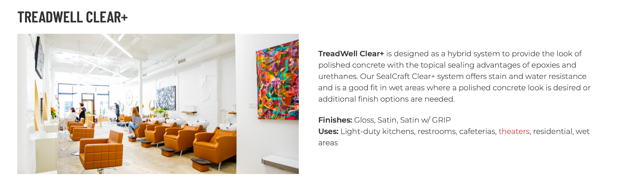
https://dancerconcrete.com/treadwell-clear/

Durability. Topical application means a completely sealed and finished floor.
Brighter Space. The finished sheen brightens the space and makes the floors look new.
Stain Protection. Increased stain protection over a polished concrete floor.
Affordable. Quicker installation times than polished concrete.

Additional Options
- Control and Construction Joint Fill
- GriT additive to improve slip resistance in wet areas

LIMITATIONS: New and existing concrete floors can be sealed with TreadWell Clear+. New concrete will be poured with moisture reduction admixture and/or relative humidity readings below 75% measured by the Wagner RH meter. Not for use in areas subject to hot tire or plastic wheeled traffic.

QUICK SPEC
DANCER CONCRETE DESIGN, TREADWELL CLEAR+
FINISHED SHEEN: GLOSS, GLOSS WITH GRIT, MATTE
Contact: Nick Dancer, 260-415-1951

Dancer Concrete Design offers AIA Accredited Courses for Polished Concrete, Epoxy Coatings, and Terrazzo Flooring in your office or ours. www.dancerconcrete.com
Please contact us for budget pricing, samples, or design considerations.
Nick Dancer. nickdancer@dancerconcrete.com c. 260-415-1951.
PART 1 – GENERAL

1.1 SUMMARY

A. Section includes products and procedure for installation of Treadwell Clear+ on concrete areas area as specified herein as indicated on drawings.

1.2 SUBMITTALS

A. Product Data: Manufacturer’s technical literature for each product indicated, specified, or required.
B. Samples: For each type of exposure, finish, or color. Sample size 3” puck or 4”x6” minimum.

1.3 QUALITY ASSURANCE

A. Qualifications: Company experienced in performing work similar in design, products, and extent to scope of this project; with a record of successful in-service performance; and with sufficient production capability, facilities, and personnel to produce specified work.

1. Manufacturer Qualification: Approved by the manufacturer of epoxy products.

1.4 FIELD CONDITIONS

A. Concrete flooring to be available and open for preparation steps. Once the floor is prepared, only allow foot traffic on the exposed surface.
B. Adequate lighting to be provided by the General Contractor or Owner before the install of flooring.
C. Area for installation to be maintained at a temperature between 60 F – 75 F.
D. A sufficient area for staging and mixing materials to be provided.
E. Building to be closed in with no water intrusion on the surface during the installation or curing process.
F. New Concrete Surfaces
1. Prohibit improper application of liquid membrane-forming curing compounds, vehicles parking over the concrete surface, pipe-cutting operations over the concrete surface, storage of items on concrete less than 28 days old, petroleum, oil, hydraulic fluid, and acids as these may all affect final finish of floor treatment.

1.5 WARRANTY

- Dancer Concrete Design warrants that material and installation is free from defects and will perform substantially.
- Dancer Concrete Design’s liability with respect to this warranty covers labor and material of the installation for a period of two years.

PART 2 – PRODUCTS

2.1 ACCEPTABLE MANUFACTURES

A. Basis of Design: for products and materials specified from TreadWell Clear+ installed by Dancer Concrete Design, Fort Wayne, Indiana. Products of the manufacturers are approved provided compliance with all technical requirements as specified herein:

- Dancer Concrete Design, TreadWell Clear+, Fort Wayne, IN. Contact Nick Dancer, 260-415-1951, nickdancer@dancerconcrete.com
- Sherwin Williams High-Performance Flooring Systems

2.2 PERFORMANCE REQUIREMENTS

A. Final Polishing Depth of Exposure
1. Aggregate Exposure is to be noted on prints for specified areas.

B. Level of Floor Reflection
1. Finished Sheen required on prints, if not listed, finished sheen TBD.

2.3 POLISHING EQUIPMENT

A. Field Finishing Equipment
1. A multiple head, counter rotating, walk behind machine, with diamond tooling affixed to the head for the purpose of grinding concrete. Excludes janitorial equipment.
2. If dry grinding, honing, or polishing, use dust extraction equipment with flow rate suitable for dust generated, with squeegee attachments.
3. If wet grinding, honing, or polishing use slurry extraction equipment suitable for slurry removal and containment prior to proper disposal.

B. Edge Grinding and Polishing Equipment: Hand-held machine which produces the same results, without noticeable differences, as field grinding polishing equipment.

2.4 REPAIR PRODUCTS

A. Mortar Patch. For areas requiring patching, a suitable color-matching cement-based product to be installed that resembles concrete. Resin-based patching will not be suitable.
a. Dancer Concrete Design; Surface Polish Patching Compound.

2.6 PRODUCTS.

- Primer - Clear, catalyzed, water-based primer to be used on a prepared concrete surface at an application rate required to seal the surface fully.
1. Products: Subject to compliance with
a. Dancer Concrete Design; TreadWell 4:1 8100 resin and hardener.

B. High-Wear Topcoat - Clear, catalyzed, water-based final topcoat for epoxy primer use. Finishes available: Gloss, Gloss with GriT, Matte
a. Dancer Concrete Design; TreadWell 4:1 4410/11 resin and hardener.

PART 3 - EXECUTION

For More Detailed Steps, please call Nick Dancer with Dancer Concrete Design – at 260-415-1951 or by email at nickdancer@dancerconcrete.com. Finishing steps vary depending on the job site conditions of concrete.

PART 3 - EXECUTION

3.1 EXAMINATION

A. Examine substrates, area and conditions regarding moisture content, installation, and any condition that could affect flooring performance.

3.2 PREPARATION

A. General

1. New and existing concrete surfaces to be free of contaminants that may inhibit proper bonding of concrete surface. No acrylic concrete sealers to be used as a curing agent.
2. Moisture testing is to be done by relative humidity testing, ASTM F 2170. For a standard installation, readings must be below 75% RH.
a. If readings are above 75% RH, additional installation methods are to be discussed.
3. The surface shall be mechanically profiled by grinding equipped with a HEPA vacuum system to maintain air quality during preparation. The minimum profile must be CSP 3-4, as detailed by ICPI.
4. Cracks and non-moving control joints to be repaired per manufacturer's specification. All cold joints to be honored through the installed system and filled with an elastomeric joint filler.

3.3 APPLICATION

A. General

1. The system shall follow the contour of the floor unless noted patching or leveling is specified by the Architect.
2. The finish shall have a neat, clean, and organized appearance with straight lines and well-defined installation boundaries.

B. Primer
1. The primer shall be TreadWell 4:1 WB Epoxy Primer. The catalyzed product shall be mixed per the manufacturer's recommendation.
2. The primer shall be applied by squeegee and roller at the rate of 200 SF per gallon.

F. High-wear Topcoat
1. The topcoat shall be TreadWell 4:1 Water-Based Urethane. The catalyzed product shall be mixed per the manufacturer's recommendation.
2. The topcoat shall be applied over a cured primer by a roller at the rate of 400 SF per gallon.

3.3 PROTECTION

A. The flooring shall be allowed to cure for 24 hours before other trades walk on the surface. The floor shall be allowed to cure 48 hours from the final topcoat until construction activities or setting of items on the floor. When setting items on the finished surface, they shall be placed on cardboard.
B. Covering: After completion of sealing, allow for proper cure and then protect sealed floors from subsequent construction activities with a protective covering. No tape is to be used on the finished surface.

END OF SECTION 09 67 23

