DESCRIPTION
StrongTread Hardwear supplied and installed by Dancer Concrete Design is a performance enhancing concrete densification and stain guard sealing system. This is proven to be superior to densifier only, or internal cure concrete admixtures.
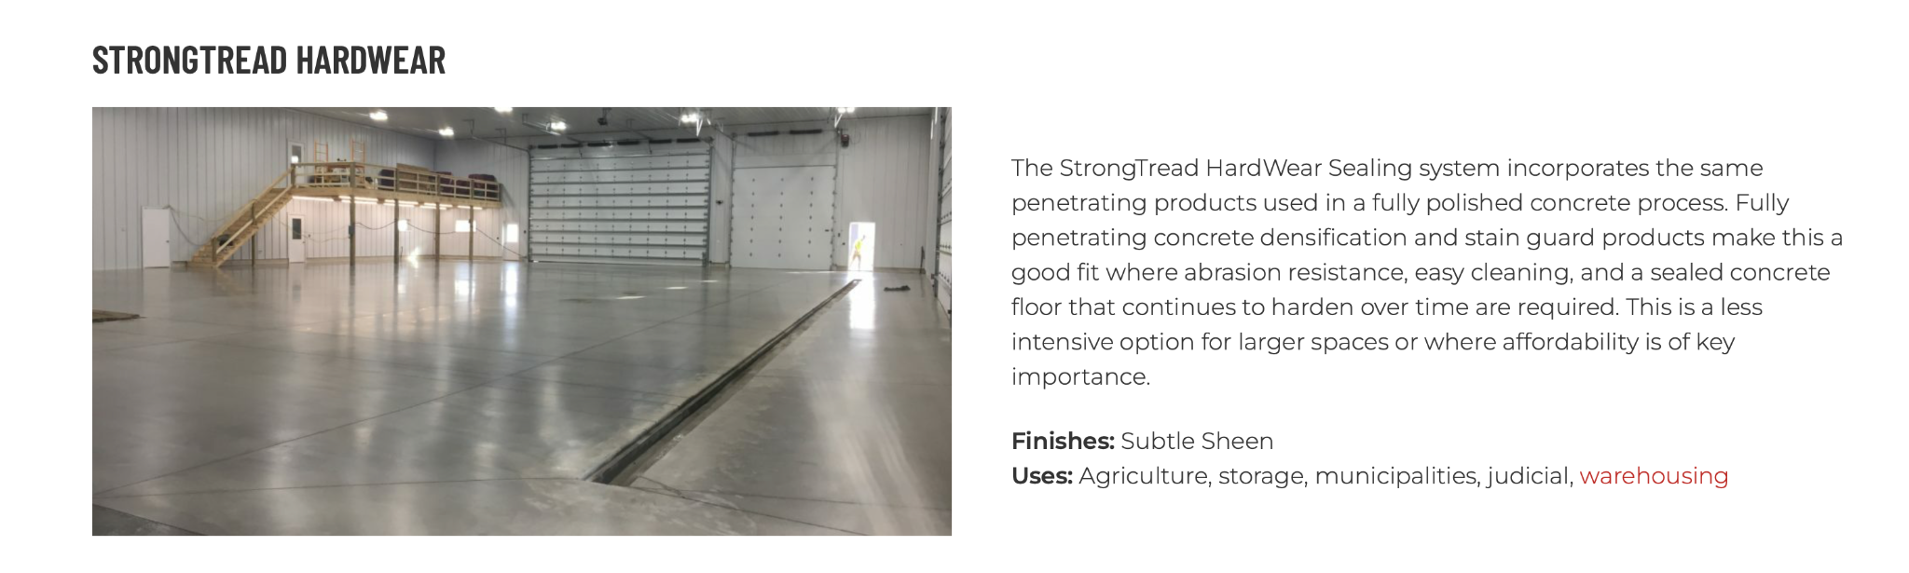
https://dancerconcrete.com/strongtread-hardwear/

Durability. Penetrating and hardening products means no chipping, peeling or dusting.
Brighter Space. Finished sheen brightens the space, and makes floors look newer longer.
Stain Protection. Allows time for spills to be cleaned up for cleaner floors.
Affordable. The most affordable long-term flooring solution for the region's best warehouses.

Additional Options
- Control and Construction Joint Fill
- StainGuard PLUS for improved stain protection

LIMITATIONS: New or existing concrete poured within ACI guidelines for steel-troweled and finished floors without previous sealers applied. Concrete remains a porous surface and is not recommended in wet rooms. For floors that require a grind to remove adhesives or previous sealants, select StrongTread Saver.

QUICK SPEC
DANCER CONCRETE DESIGN, STRONGTREAD HARDWEAR SEALING
FINISHED SHEEN: SUBTLE SHEEN
Contact: Nick Dancer, 260-415-1951

Dancer Concrete Design offers AIA Accredited Courses for Polished Concrete, Epoxy Coatings, and Terrazzo Flooring in your office or ours. www.dancerconcrete.com
Please contact us for budget pricing, samples, or design considerations.
Nick Dancer. nickdancer@dancerconcrete.com c. 260-415-1951.

PART 1 – GENERAL

1.1 SUMMARY

A. Section includes products and procedure for multiple step concrete polishing process for designated area as specified herein as indicated on drawings.

1.2 SUBMITTALS

A. Product Data: Manufacturer’s technical literature for each product indicated, specified, or required.
B. Samples: For each type of exposure, finish or color.

1.3 QUALITY ASSURANCE

A. Field Sample Panels: After approval of samples, produce field sample panels to demonstrate range of selections made under sample submittals. Produce full-scale panels to demonstrate the expected range of finish, color, and appearance variations.

1. Locate panel as indicated or, if not indicated, as directed by the Architect.
2. Maintain field sample panels during construction in an undisturbed location as a standard for judging completed work.

B. Qualifications: Company experienced in performing work similar is design, products, and extent to scope of this Project; with a record of successful in-service performance; and with sufficient production capability, facilities, and personnel to product specified work.

1. Manufacturer Qualification: Approved by manufacturer to apply liquid applied products.

1.4 FIELD CONDITIONS

A. Damage and Stain Prevention: Take precautions to prevent damage and staining of concrete surfaces to be polished.

1. Prohibit improper application of liquid membrane forming curing compounds, vehicle's parking over the concrete surface, pipe-cutting operations over concrete surface, storage of items on concrete less than 28 days old, petroleum, oil, hydraulic fluid, and acids as these may all affect final finish of floor treatment.

PART 2 – PRODUCTS

2.1 ACCEPTABLE MANUFACTURES

A. Basis of Design: for products and materials specified from Hardwear Floor System installed by Dancer Concrete Design, Fort Wayne, Indiana. Products of the manufactures are approved provided compliance with all technical requirements as specified herein:

2.2 PERFORMANCE REQUIREMENTS

A. Exposure
1. Aggregate Exposure Class A – Cream Finish: Surface resulting in little to no aggregate exposure.

B. Level of Floor Reflection
1. Finished Gloss – Subtle Sheen

2.3 LIQUID FLOOR TREATMENTS

A. Penetrating Liquid Floor Treatments for Polished Concrete, Densifier: Clear, waterborne solution of inorganic silicate or siliconate materials and proprietary components; odorless, that penetrates, hardens, and is suitable for polished concrete surfaces.

1. Products: Subject to compliance with
a. Dancer Concrete Design; StrongTread Densifier
b. Prosoco, LS/CS Densifier on new concrete. LS Densifier for existing.

B. Semi-Penetrating Stain Guard: A micro film forming material which will penetrate into the polished and densifier concrete leaving a protective surface film.
a. Dancer Concrete Design; StrongTread Stain Guard SPF
b. Prosoco: LS Guard

PART 3 - EXECUTION

For More Detailed Steps please call Nick Dancer with Dancer Concrete Design – 260-415-1951 or by email at nickdancer@dancerconcrete.com. Finishing steps vary depending on the job site conditions of concrete.

3.1 EXAMINATION
A. Verify that floor surfaces are acceptable to receive the work of this section.
B. Verify that flaws in concrete have been patched and joints filled with methods and materials suitable for further finishes.

3.2 GENERAL
A. Apply materials in accordance with manufacturer's instructions.

3.3 PREPARATION
A. Verify that surface is free of previous coatings, sealers, curing compounds, water repellents, laitance, efflorescence, fats, oils, grease, wax, soluble salts, residues from cleaning agents, and other impediments to adhesion.
B. Protect adjacent non-finished areas from damage, overflow, overspray, etc., immediately remove excess material.

3.4 FINISHING
A. Mechanical and chemical cleaning process to remove surface impurities and prepare the surface for densifier.
B. Apply penetrating liquid densifier for polished concrete in polishing sequence and according to manufacturer's written instructions, allowing recommended drying time between successive coats.
C. Apply specific stain guard treatment to floor and complete final burnishing with appropriate diamond impregnated burnishing pad or buffing pad.
D. High Speed Burnish Floor to obtain proper sheen.

END OF SECTION 033543

